**Name: Aarya Tiwari**

**Roll No : 16010421119**

**Batch A3**

**Experiment Number: 5**

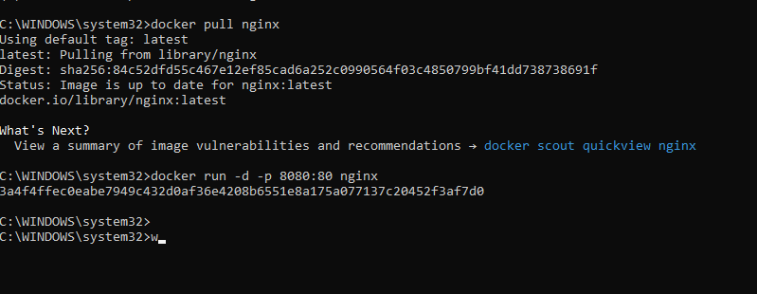

Nginx is running

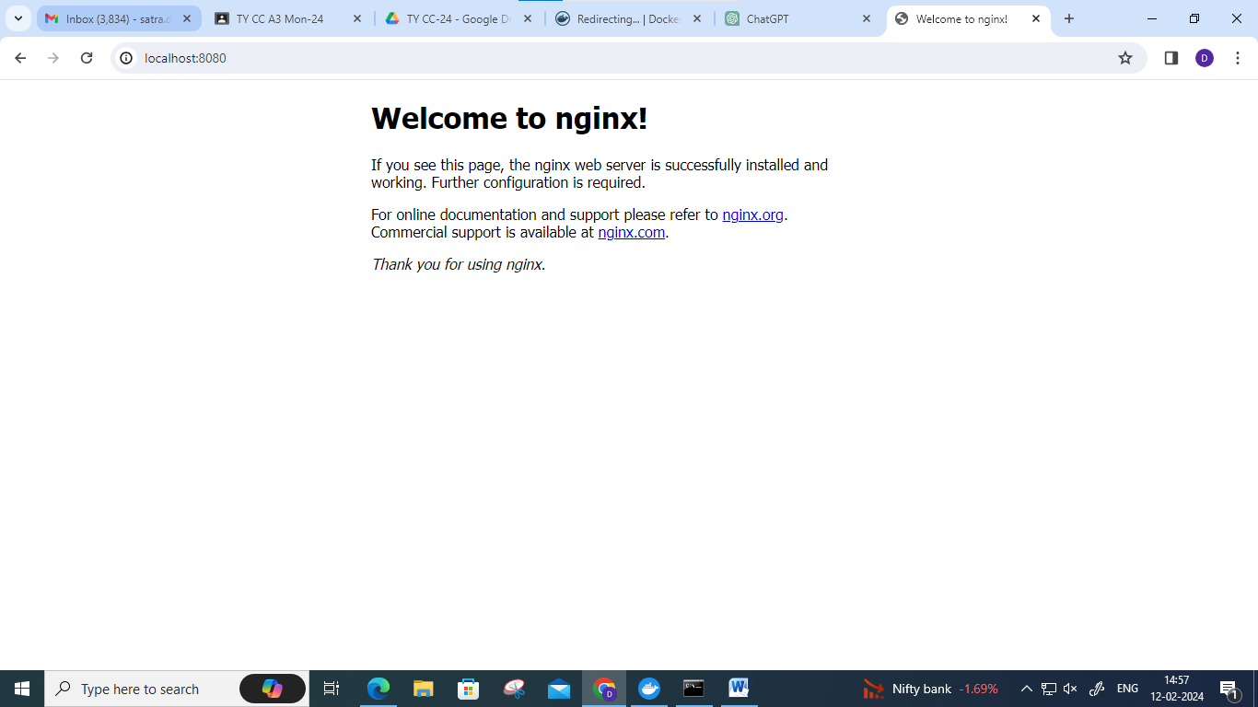

**Push Nginx Image to Docker Hub**:

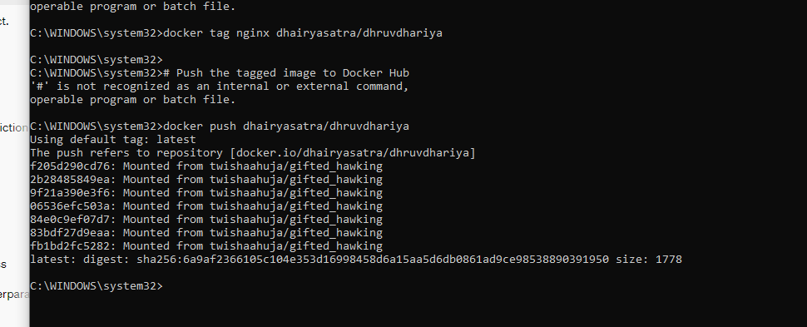

Push successfully to docker app.

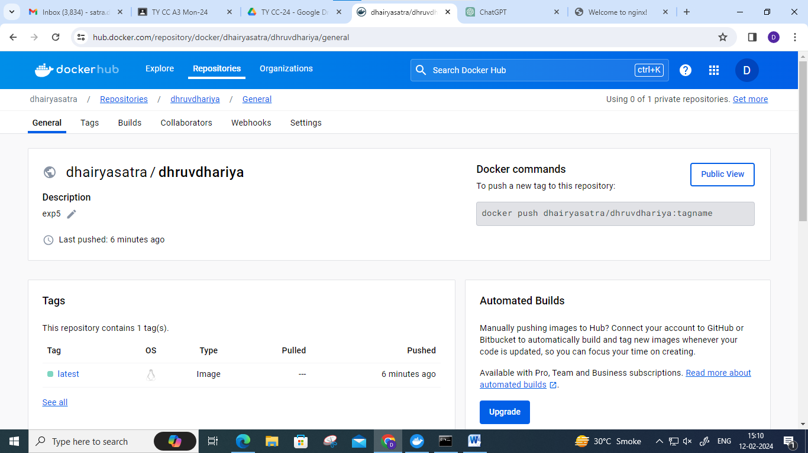

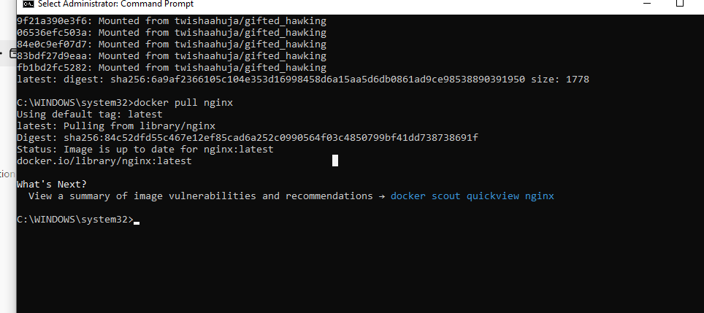

Dockerfile for python script:

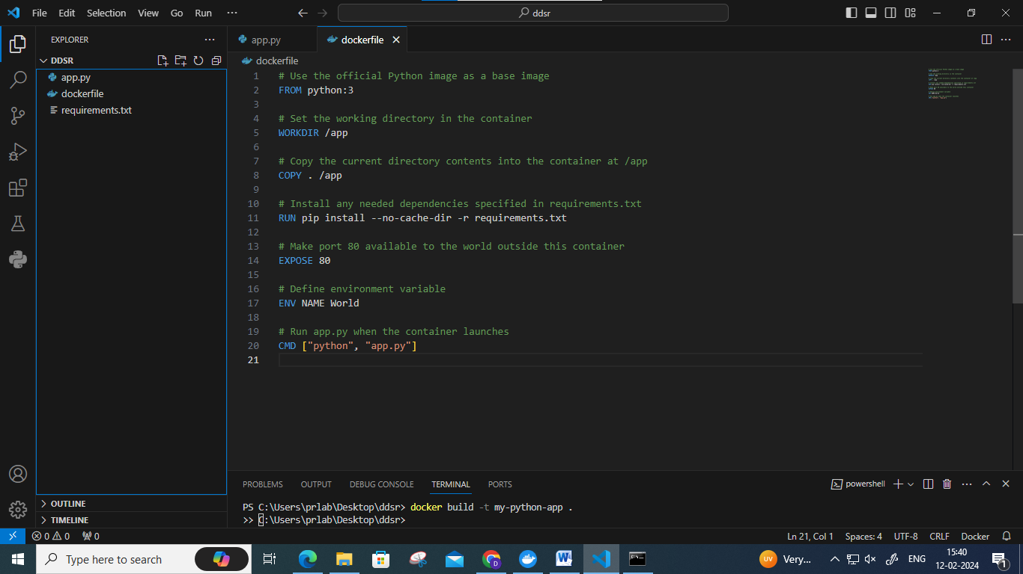

Docker image created for python script

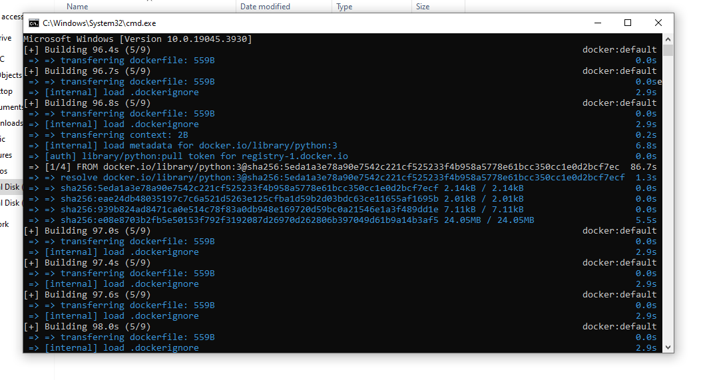

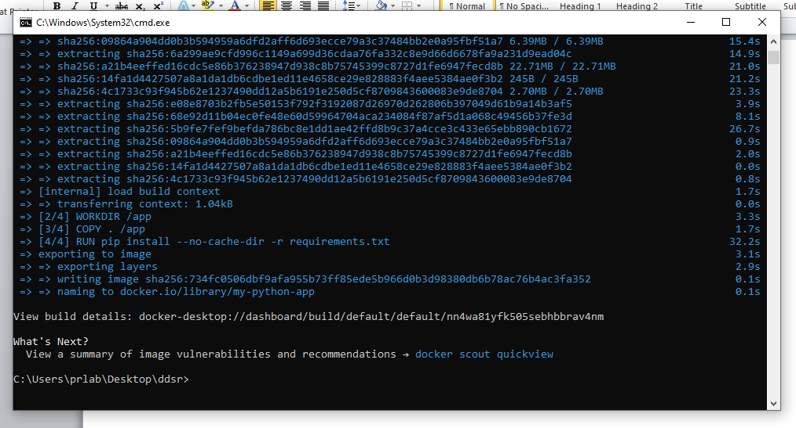

Running python script via docker image

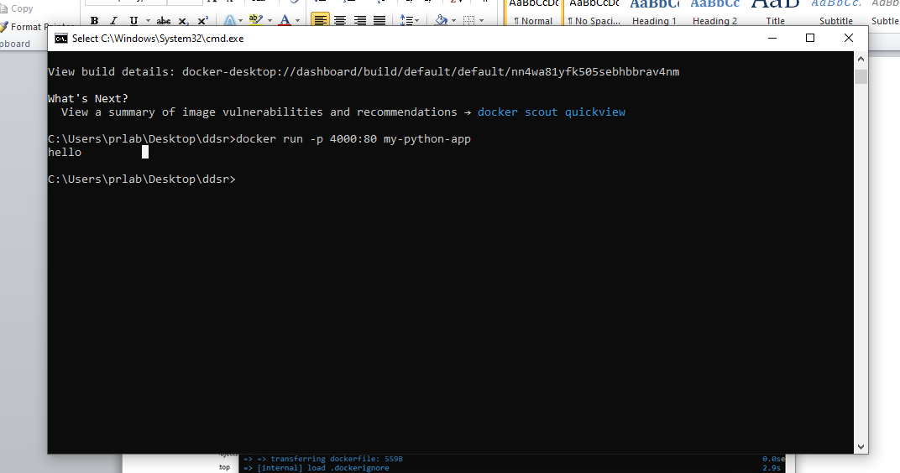

Pushing py.-script image to docker

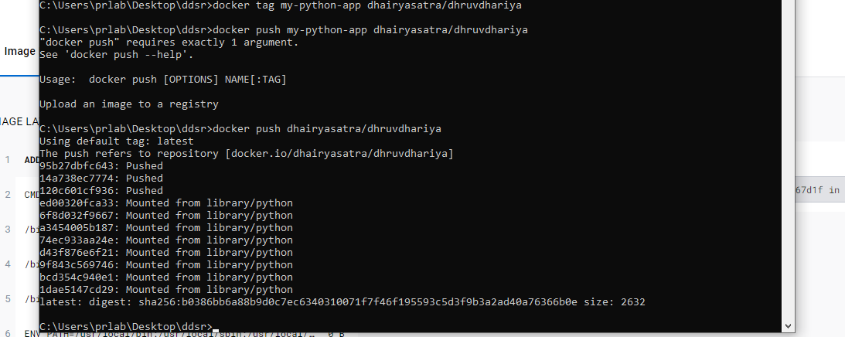

Python script image pushed to repo.

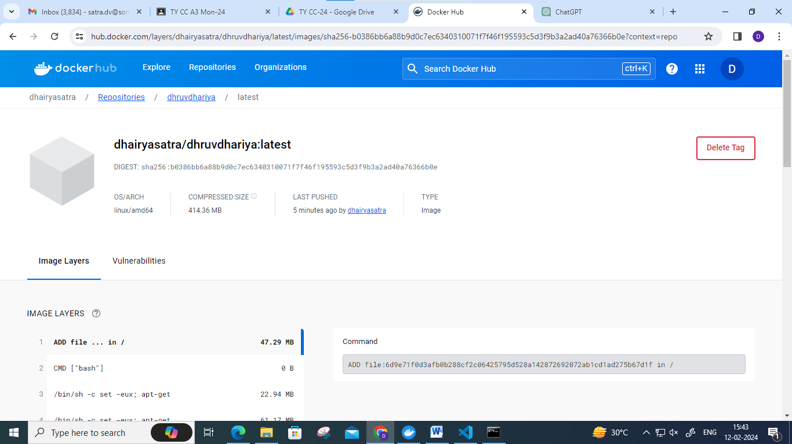

Creating docker file

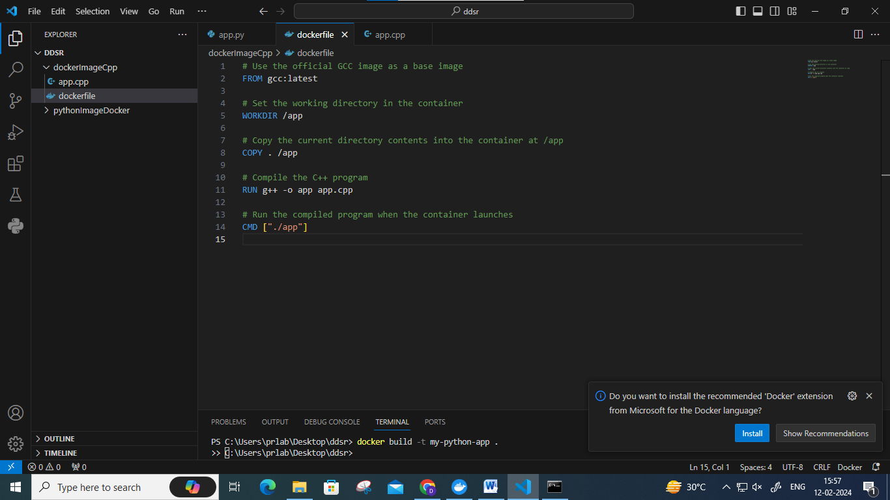

Creating docker image

docker build -t cpp-program .

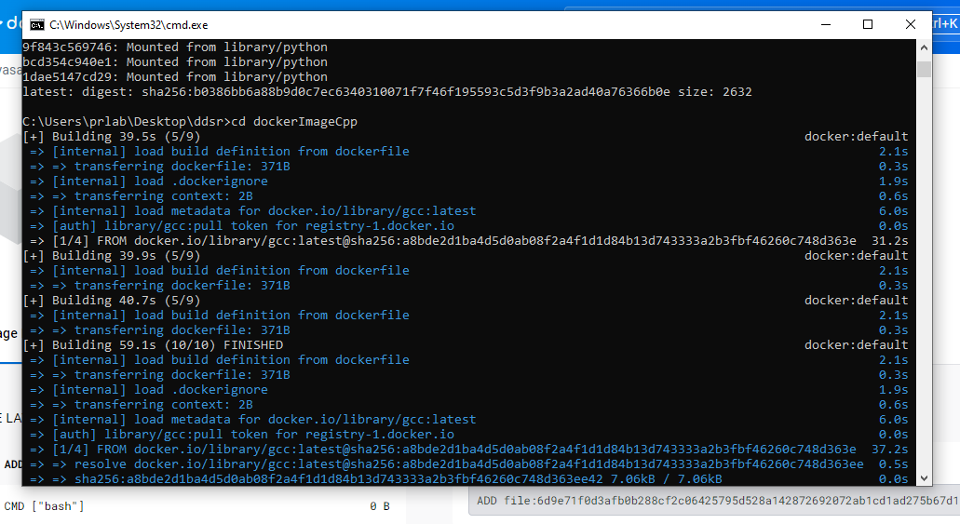

Running c++ image

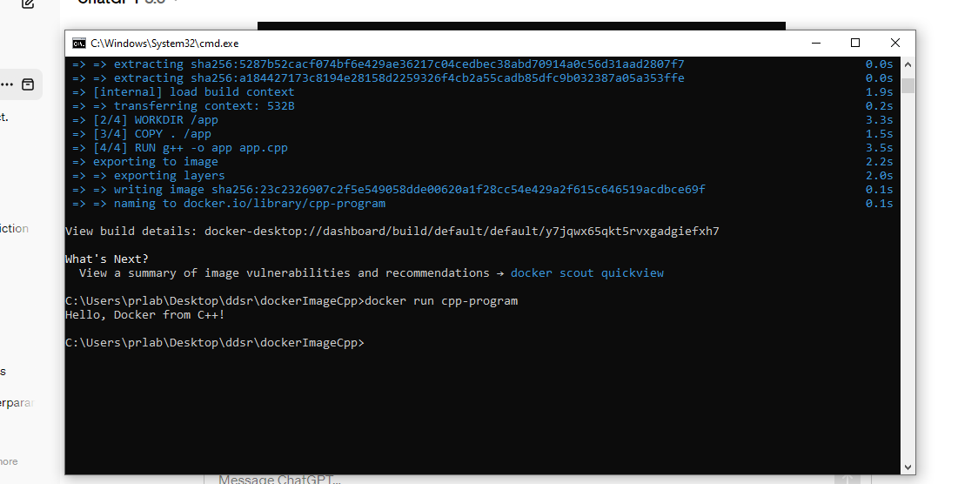

Pushing cpp image to repo

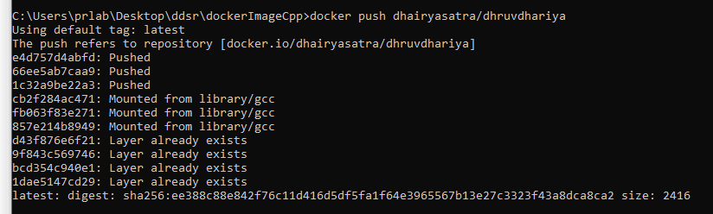

**Post Lab Questions:**

**Q1. What is Docker file?**

Ans.

A Dockerfile is a text document that contains instructions for building a Docker image. It essentially acts as a recipe that specifies the steps required to create a standardized, executable package of your application. Here's a breakdown of its key aspects:

**Outcomes:**

CO3: Analyze different cloud architectures and IOT-cloud

**Conclusion:**

We can conclude that we have learnt about Running an application in a container, Docker and

Docker Hub